**National University of Computer and Emerging Sciences**



**Lab Manual 11**

**Object Oriented Programming**

4th June, 2021

|  |  |
| --- | --- |
| Course Instructor | Miss Abeeda |
| Lab Instructor (s) | Ms. Abiha Aftab  Mr. Dilawar Shabbir |
| Section | B |
| Semester | Spring 2021 |

Department of Computer Science

FAST-NU, Lahore, Pakistan

# **Objectives**

After performing this lab, students shall be able to:

* Perform exception handling.
* Performing Multiple inheritance

**Multiple Inheritance**

# **Exercise 1:**

Create two classes named Mammals and MarineAnimals. Create another class named BlueWhale which inherits both the above classes. Now, create a function in each of these classes which prints "I am mammal", "I am a marine animal" and "I belong to both the categories: Mammals as well as Marine Animals" respectively. Now, create an object for each of the above class and try calling  
1 - function of Mammals by the object of Mammal  
2 - function of MarineAnimal by the object of MarineAnimal  
3 - function of BlueWhale by the object of BlueWhale  
4 - function of each of its parent by the object of BlueWhale

# **Exercise 2:**

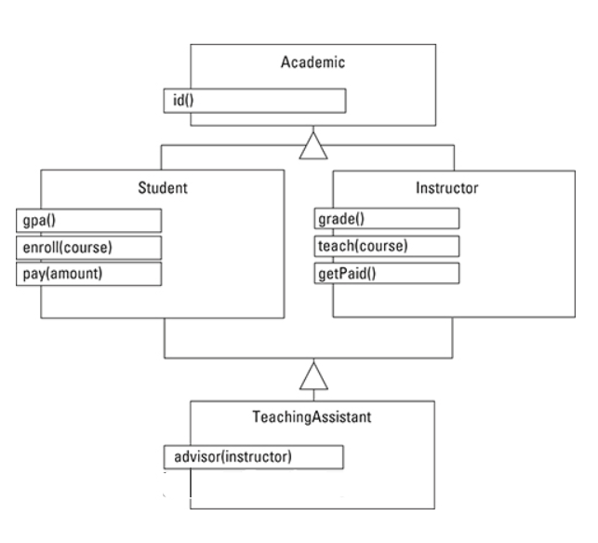

For the given above class diagram, implement the entire hierarchy of the Class diagram i.e. define all the classes along with their attributes and their inheritance.

**Exception Handling**

# **Exercise 3:**

Write a program that prompts the user to enter a person’s date of birth in numeric form such as 8-27-1980. The program then outputs the date of birth in the form: August 27, 1980. Your program must contain three exception classes: **invalidDay, invalidMonth,** and **invalidYear**. If the user enters an invalid value for day, then the program should throw and catch an **invalidDay** object. Follow similar convention for the invalid values of month. Handle leap year value with **invalidYear** exception.